STUDENT ID: 2020H1120904U

STUDENT NAME: Raghav Venkatesh

PROJECT TITLE: Decision Tables

AREA OF MINI PROJECT: Designing and evaluating a Decision Table Majority (DTM). Utilization of foremost probe and estimating forecasting correctness with multi-level corroboration

SIGNIFICANCE

Evaluating ability for resolving chart as supposition volume for administered research data. Resolving charts are a simple hypothesis space, and normally they are easy to understand. On artificial and real-world domains containing only discrete features, IDTM, an algorithm inducing decision tables, can sometimes outmatch modern ones. Plenty of registers used in tool education don't utilize these characteristics, or characteristics comprise of low numbers. Description of a gradational technique for doing corroboration that’s utilizable to gradational training techniques. Utilizing gradational hybrid-corroborate, it's probable to hybrid-corroborate given data records,IDTM in time linear to amount of occasions, amount of characteristics as well as amount of tag prices. Goal isn’t about exhibiting fixed technique for choosing characteristics is great, instead exhibiting a minimum of one technique for choosing layout is brilliant.

DATASET

Datasets used on discrete domain are audiology,cancer,chess,corral,dna,lenses,lung-cancer,monk,mushroom,parity,tic-tac-toe and vote. The number of features is 489. The number of samples are 16432.

Datasets used in non discrete domain are australian,cancer,cleve,crx,diabetes,german,glass,hayes-roth,heart,hepatitis,horse-colic,hypothyroid,iris,labor,letter,lymphography,satimage,segment,sick-euthyroid,soyabean-small,vehicle. The amount of characteristics is 372. The amount of samples are 34799.

Link for datasets is ftp:/pub/machine-learning-databaseonics.uci.edu.

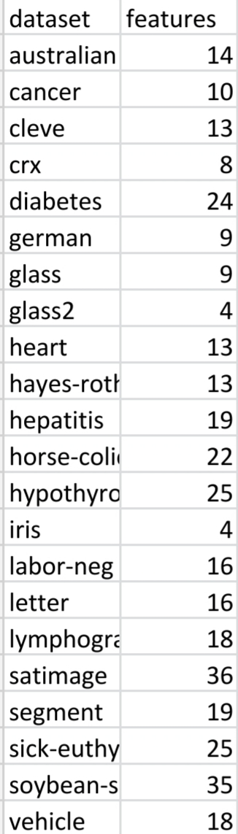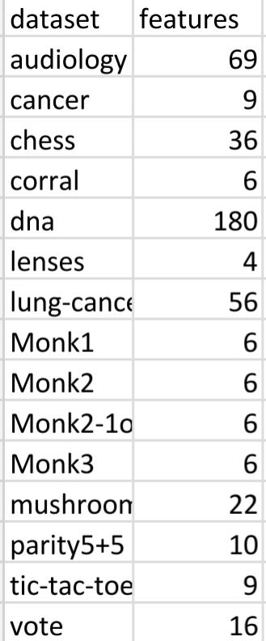

OBJECTIVES

To show resolving chart having unvarying precept plotting to bulk group is utilized for segmenting occurrences in detached volumes with precision occasionally higher than initiating discoveries. Resolving Charts are simple to decipher if not large. Proving that resolution charts provide a very good conjecture volume for initiation process. Showing that a simple hypothesis space can lead to great result. Showing how hybrid-corroboration of RCM and data records can be completed in time that's linear to amount of occurrences, amount of characteristics and amount of tags.

APPLICATION

Decision Tables help in better estimation. Also aids in choosing a part of characteristics that executes well and provides a beginning region for a characteristic part choosing utilizing processes having greater difficulty. This helps in formalizing concept of a gradational hybrid-corroboration process utilizable whenever an initiation process aids gradational adding as well as deleting tasks. Using this technique to show how hybrid-corroboration of an RCM and data record can be executed in time that's linear in amount of occurrences, the amount of characteristics and amount of tags.

For proving gradational hybrid-corroboration aids in quick precision approximates for resolving chart initiation process. RCM can be utilized to choose a division of occurrences that execute well and provide a beginning area for occurrence division choosing search utilizing difficult process. It’s possible to trial valuable initiation routines making new characteristics (e.g., interlude quantization) through the above process.

MODEL

Model used for design of decision tables is Cover Version. Initiation process is utilized as contraption, and forage in expanse of occurrence divisions is made by a "cover" process.

For aimed task f’ as well as conjecture H’, assigning of optimum occurrences utilized in conjecture h’ in H’ having largest forecasting precision corresponding to f’.

For untagged occurrence I’, tag allocated to occurrence by RCM classifier is measured as follows.

Supposing g’ be set of tagged occurrences in RCM same as occurrence I, where occurrences on layout are needed to be same and remaining occurrences are left out. In case I’= 0, major division in RCM is yielded; else, major division in Z’ is yielded. Undisclosed amounts are considered as distinct amounts in complementing process.

FEATURE SUBSET

An ideal characteristic division, A\*, for given conjecture volume H’ and aimed task f’ is division of characteristics A\*\* such that there is a conjecture h’ in H’ utilizing characteristics of A\* and possessing minimal error corresponding to aimed task f’.

States in volume are characteristic divisions; operators could be adding as well as deleting a characteristic. Beginning node can be group of all characteristics or null groups and computing task is hybrid-corroboration.

INCREMENTAL CROSS-VALIDATION

The concept in gradational hybrid-corroboration is rather than tutoring k occasions on k -1 folds each occasion, there is tutoring in complete data records, then deleting of instances in a bunch, testing on the same bunch, and inserting of occurrences once more.

Nearest neighbour algorithms aid in incremental adding and deleting of instances through simple addition and removal of prototype points.

For classification of an instance, unlabelled instance is found in hash table and label corresponding to largest counter value is returned.

For deleting an instance, underlying unlabelled instance is detected and corresponding label counter is reduced by one; if all counters are 0, the underlying unlabelled instance’s deleting is carried out.

CHOOSING NUMBER OF FOLDS

For linear versions, using leaving single entity hybrid-corroboration for version choosing is asymptotically irregular since probability of choosing through largest forecasting strength doesn’t close in on one as total amount of findings gets closer to infinity.

For moderately sized data sets, 10 to 15 folds are good selections.

Experimentally, utilizing ten-fold hybrid-corroboration is superior compared to leaving single entity form.

MONKOne PROBLEM

The MonkOne record has common tutoring and trial group. There aren't any identical occurrences, there isn't any buzz in tutoring groups. A RCM with layout having occurrences and trialled on a trialled group detached from tutoring group always vaticinates major divisions; hence it's similar to an initiation process forecasting same task--correct or incorrect, corresponding to major division in tutoring group.

Supposed precision through leaving single entity or hybrid-corroboration on a RCM with all characteristics(or similarly, a major initiation) as well as tutoring group for MonkOne record is zero percent. The case illustrates natural issue with hybrid-corroboration utilizing to more than major initiator.

RESULT ACCURACY

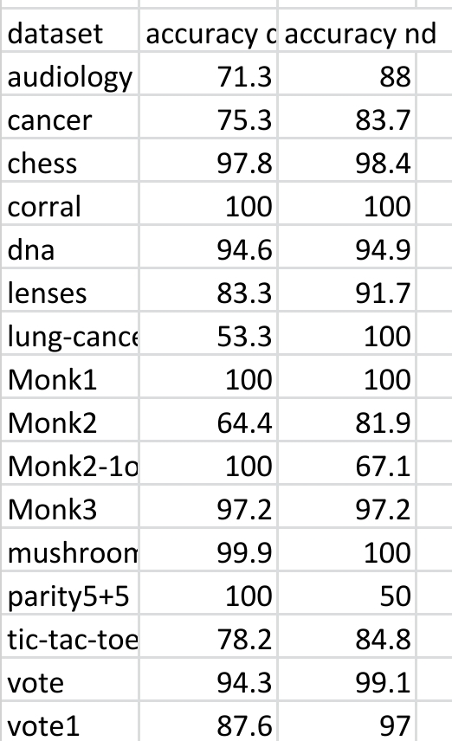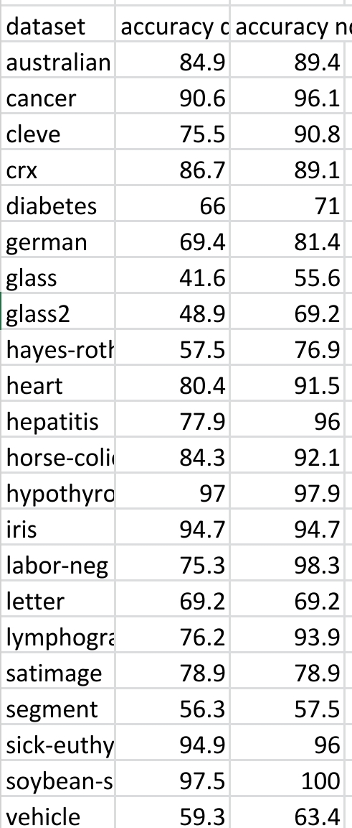

Result Accuracy is 83.46 percent

REFERENCES

Ronald Kohatvi, “ Strength of Various Decision Tables", 2019